### **PRASATH D - 212221020033**

### **Exp 8: Reproducing an Image Using Prompts for Image Generation**

### **Aim:**

To demonstrate the ability of text-to-image generation tools to reproduce an existing image by crafting precise prompts. The goal is to identify key elements within the image and use these details to generate an image as close as possible to the original.

### **Procedure:**

1. **Analyze the Given Image:**
   * Examine the image carefully, noting key elements such as:
     + **Objects/Subjects** (e.g., people, animals, objects)
     + **Colors** (e.g., dominant hues, contrasts)
     + **Textures** (e.g., smooth, rough, glossy)
     + **Lighting** (e.g., bright, dim, shadows)
     + **Background** (e.g., outdoor, indoor, simple, detailed)
     + **Composition** (e.g., focal points, perspective)
     + **Style** (e.g., realistic, artistic, cartoonish)
2. **Create the Basic Prompt:**
   * Write an initial, simple description of the image. For example, if the image shows a landscape, the prompt could be "A serene landscape with mountains and a river."
3. **Refine the Prompt with More Detail:**
   * Add specific details such as colors, mood, and time of day. For example: "A serene landscape during sunset with purple mountains, a calm river reflecting the colors of the sky, and a few trees along the shore."
4. **Identify Style and Artistic Influences:**
   * If the image has a particular style (e.g., impressionist painting, realistic photography, minimalistic), include that in the prompt. For example: "A serene landscape in the style of a watercolor painting with soft, blended colors."
5. **Adjust and Fine-tune:**
   * Refine the prompt further by adding specific instructions about elements like textures, weather conditions, or any other distinctive features in the image. For example: "A serene landscape during sunset with purple mountains, a calm river reflecting the colors of the sky, a few trees along the shore, and soft, pastel tones in the clouds."
6. **Generate the Image:**
   * Use the crafted prompt to generate the image in a text-to-image model (e.g., **DALL·E**, **Stable Diffusion**, **MidJourney**).
7. **Compare the Generated Image with the Original:**
   * Assess how closely the generated image matches the original in terms of colors, composition, subject, and style. Note the differences and refine the prompt if necessary.

### **Deliverables:**

* + - 1. **The Original Image:**

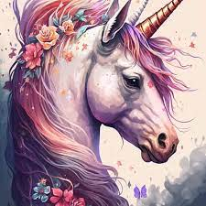

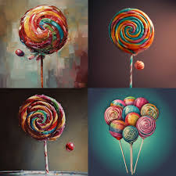

* + - 1. **The Final Generated Image**:

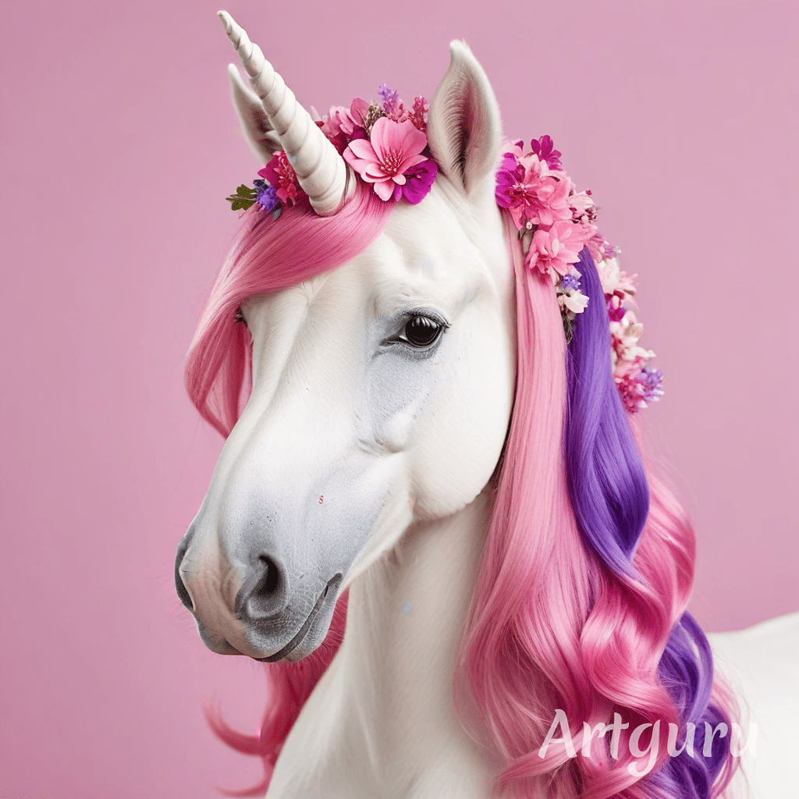

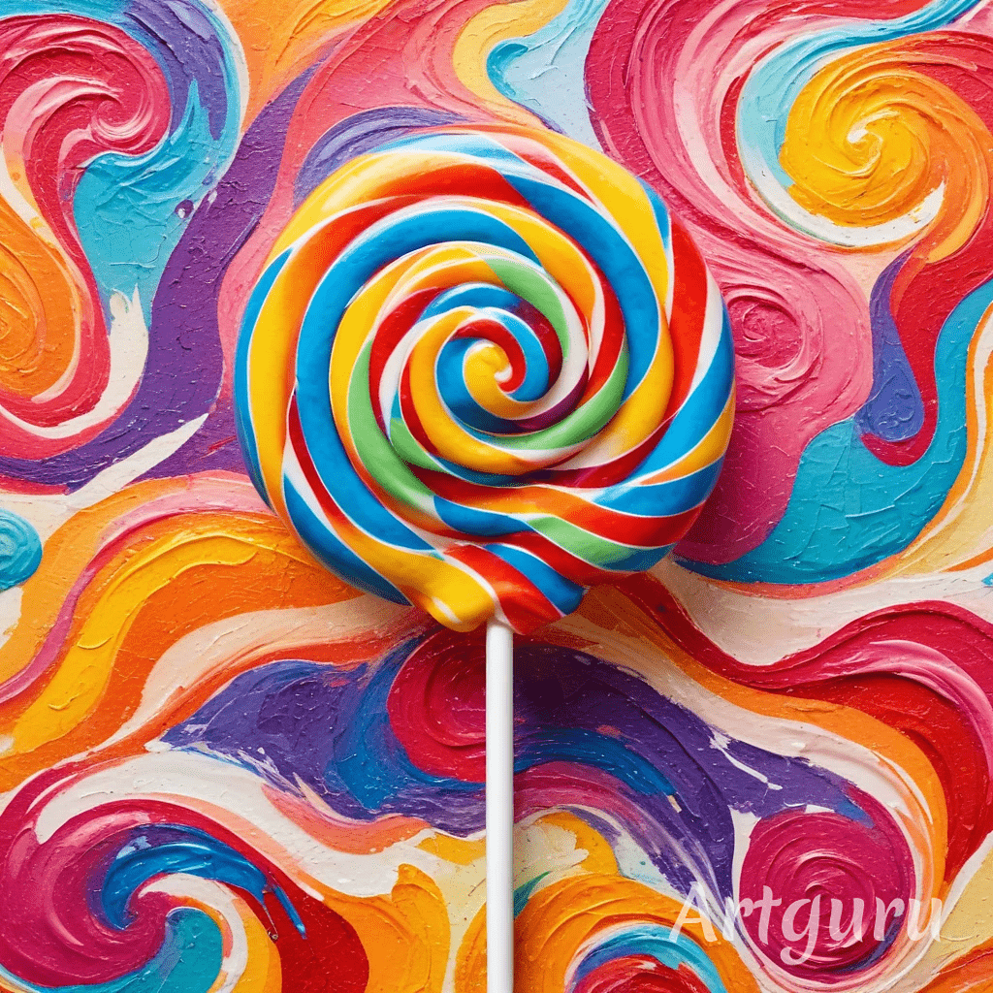

1. **Prompts Used**:

**Prompt 1**: "Create a highly detailed, photorealistic unicorn with a white coat. The unicorn should have a long, flowing pink and purple mane, adorned with vibrant flower crowns. The background is soft pink to emphasize the magical and serene atmosphere. The unicorn's expression is gentle, and the lighting is soft and diffused, creating a dreamlike quality."

**Prompt 2**: "Create a vibrant and colorful lollipop with a rainbow swirl pattern at the center. Place it against an abstract, painted background of swirling, multicolored waves in a thick, textured style. The colors should be bold, with shades of red, blue, yellow, and orange dominating the palette. The overall vibe should be playful and visually dynamic, evoking a sense of whimsy and joy."

1. **Comparison Report**:

**Core Elements**: The original and generated images maintain the core elements described in the prompt.

**Color scheme**: The color schemes in generated images follow the descriptions.

**Style and Mood**: The generated images match the style and mood intended in the original prompt.

### **Conclusion:**

By using detailed and well-crafted prompts, text-to-image generation models can be effective in reproducing an image closely. The quality of the generated image depends on how accurately the prompt describes the image's key elements. The experiment demonstrates the importance of prompt refinement and iteration when working with AI tools to achieve desired outcomes. With practice, the model can generate images that closely match real-world visuals, which is useful for creative and practical applications.